The Holocaust Digital Writing Projects
Please contact me with any questions. Read the entire document.

Projects are due: (edit as needed) at the beginning of class. You must have your project printed, uploaded, published, or recorded (depending on which one you choose) by this date (edit as needed). You may bring your project to me before school begins on the day of (edit as needed). I will not be responsible for housing projects before this date. We will have some time to work on the projects in class; however, MOST of the projects will be completed on the student’s own time, as work from home, during forum, or after school. You have one full week to work on and complete this task.

If you have any questions regarding projects, be proactive and contact me as soon as possible. Your grade for this class comes from the work of your portfolio and this important multimedia project.

Quality work = Quality grade!

We HIGHLY recommend that you start your project NOW. Don’t wait until the last minute. The following will provide you with a few tips and tricks:

Red: Stop (I’m not good with technology and I don’t have a computer at home)
You should select the artistic expression assignment. This way, you simply need poster paper (provided by your teacher – just ask), colored pencils/markers, and your mad art skills! You will still be responsible for the written portion of the assignment, too.

Yellow: Slow (I’m alright with technology… where should I begin – I’m a fast learner)
You would be safe starting with the glogster assignment or the storybird assignment. Both websites are easy to navigate and fairly straight forward.

Green: Go! (I’m a techy wiz and love to work with my computer. I can upload, save, embed, export…)
You are ready to get started with the weebly assignment or the capzles assignment. There are more steps involved with these websites; however, the end products look really cool if you can pull it off!

For those of you working with websites, the following are ideas you may use to jazz up your projects:

- add a Voki
- embed a youtube or schooltube stream
- upload a document or powerpoint or slideshare
- import a make believe comix
- create and add a blabberize
- import mp3 appropriate files
- make and embed an animoto film

Project Choices: Glogster, Weebly, Capzles, Storybird, Artistic Expression
*All projects include a written assignment. See each project’s guidelines for exact specifications. (Weebly and Capzles must have the written assignment included as part of the presentation/project)

Project Choices: select one: Due: (edit as needed) (beginning of class)
NO LATE WORK WILL BE ACCEPTED! GRADES ARE FINAL!

Glogster

http://www.glogster.com/

You will need to register and set up a free account. Remember as with any project or assignment, as soon as you have an issue – see ME before it becomes a problem. I can NOT help you the day it is due. You have one full week to complete the assignment. You have my phone #, email, and room #.

Requirements: follow EACH step carefully in order to receive FULL credit

- be creative
- must look professional
- use academic language and vocabulary
- check grammar and spelling (proper nouns = capital letter!)
- at least 1 video segment included
- at least 2 images
- at least 4 text boxes explaining your work/images/video
- nice flow of graphics – everything seems to go together and match
- if including audio/mp3, must be appropriate
- if including links or any additional multimedia – all must work
- must show a strong display of background knowledge
- images must be clear, crisp, and easy to view

Turn In: email me the url (website address/link) so that I may find and view your project

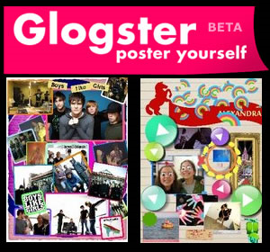

Capzles

http://www.capzles.com/

You will need to register and set up a free account. Remember as with any project or assignment, as soon as you have an issue – see ME before it becomes a problem. I can NOT help you the day it is due. You have two full weeks to complete the assignment. You have my phone #, email, and room #.

Requirements: follow EACH step carefully in order to receive FULL credit

- be creative
- must look professional
- use academic language and vocabulary
- check grammar and spelling (proper nouns = capital letter!)
- be careful… whatever you save your images as, that will appear on your presentation (so save them so that they briefly explain what the image is and that it is spelled correctly)
- nice flow of graphics – everything seems to go together and match
- must include audio/mp3, must be appropriate
- if including links or any additional multimedia – all must work
- must show a strong display of background knowledge
- images must be clear, crisp, and easy to view
- images must appear in a logical order to show a sequential timeline
- must include at least 16 images (not counting the additional documents in Word)
- must include at least 4 documents (written in Microsoft Word) spell check your work!
- after every few images (every three or so…) include a written paragraph in a Microsoft Word document that you will upload/import as a file just as you have done with the images. Therefore, your total presentation will include written work of at least four paragraphs. These paragraphs should be written in third person (google this if you forgot!!). They should sound professional just as though someone is viewing your presentation for research. Be specific – use times, dates, places, people, etc…
- Total presentation = at least 20 slides

Turn In: email me the url (website address/link) so that I may find and view your project

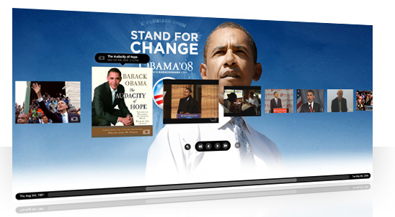

Storybird

http://storybird.com/

You will need to register and set up a free account. Remember as with any project or assignment, as soon as you have an issue – see ME before it becomes a problem. I can NOT help you the day it is due. You have two full weeks to complete the assignment. You have my phone #, email, and room #.

Requirements: follow EACH step carefully in order to receive FULL credit

- be creative
- must look professional
- use academic language and vocabulary
- check grammar and spelling (proper nouns = capital letter!)
- nice flow of graphics – everything seems to go together and match
- must show a strong display of background knowledge
- must include at least 8 (10-14 preferably) pages – (1/2 pages don’t count as a full page).
- Each page must have at least 2 complete, full, and rich sentences… UNLESS (be very careful with this…) you may choose to use less words on a page, perhaps even a single word on a page – like BOOM or CRASH – to enhance the story’s effect; however, your total story must have at least 16 full, complete, and rich sentences. SPELLED CORRECTLY!!!
- You may choose to write a story for a young child, a middle school aged child, or an adult-style picture book. Whichever you choose, be detailed with your work.
- must show a strong display of background knowledge
- you must present the information in a logical, sequential manner
- you may choose the ‘once upon a time’ theme or a perspective such as non-fiction

Turn In: email me the url (website address/link) so that I may find and view your project

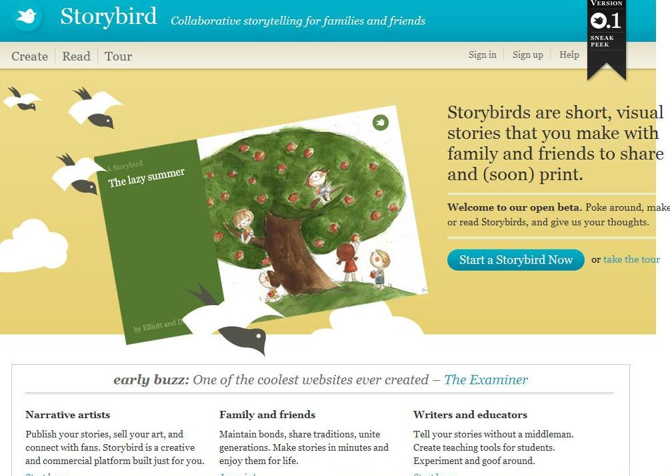

Make a website

For help to create a site for free: www.weebly.com

You will need to register and set up a free account. Remember as with any project or assignment, as soon as you have an issue – see ME before it becomes a problem. I can NOT help you the day it is due. You have two full weeks to complete the assignment. You have my phone #, email, and room #.

Requirements: follow EACH step carefully in order to receive FULL credit
You are to create a website that features The Holocaust. Some ideas for pages that you could include are:
- timeline of events
- information about the concentration camps
- stories from survivors
- what life was like during this time period
- parallels between The Holocaust and another book of your choice…
- a moment of silence or respects page for the lives lost
- a blog for interaction from site visitors

You must have at least four pages (home page, and three detail pages). Each page must be designed with photos and text. You must have at least one image per page and at least one full paragraph (4 – 5 sentences) on each page. At least one page must include multimedia (voki, video/youtube, etc…)

Turn In: email me the url (website address/link) so that I may find and view your project

CHALLENGE: (this is optional – only for those who wish to try the challenge…)

For those of you that would like to take this project to the next level:
You may select a group of 4 to work with. If you choose to do this – you MUST GET APPROVED by me FIRST. I will only approve those to work in a group who are confident in their technology skills, who have worked with website design in the past, and who maintain grades that reflect dedication to his or her work habits.

The task:

Each person in your group completes one of the following: Glogster, Weebly, Capzles, and Storybird. Together, you must incorporate each form of multimedia (Glogster, Capzles, and Storybird) into the website (Weebly). This will be fun and challenging – what a wonderful opportunity for those who wish to try. Your group will be given at least 1 full day of out of class time to collaborate on your project together.
Additionally, you will need my username and password for her weebly account so that you may develop a site that supports such multimedia. See me for details.

Whoo hoo – I look forward to seeing all of your creativity!!! Hugs! ☺ Your Teacher!

Artistic Expression

You DO NOT need a computer for this project. (any part of it)

Part 1:
For this project, you are to design a poster displaying a type of propaganda used by the Nazi’s during this time period OR you are to design a poster of a front page news heading showing the tragedy of what happened. You may use a poster board, add color, and detail. You may also use any additional resources/crafts to enhance your project (fuzzy sticks, cotton, glitter, etc…)

Part 2:
You are to write a 4 paragraph paper explaining the following: (1)events leading up to the event, (2)what time period this happened during and what was going on around the world,(3) what happened to the different people of this time, and (4) the effects of the aftermath.

Your paper must be written PROFESSIONALLY (correct grammar, spelling, academic word choice).
Your poster must look authentic, or real. It must include a great amount of detail!!!
This should take a lot of time to complete, and your work must display that you truly have a great understanding of the study we have done in class along with the work your researched.

Turn In: Your beautifully crafted poster and your neatly written paper.

Please check out the class website. You will find the following:

- video segments of tutorials to learn how to use the project websites
- website links to access quality information about The Holocaust
- a variety of search engines to help refine your hunt
- video segments of information regarding The Holocaust
- a contact form for any questions you may have

Good Luck – again… your projects are due at the beginning of class on (edit as needed). No late work will be accepted. You have 1 full week to complete the project. Project grades weigh heavily on your semester averages.

Contact us, in advance if you have any questions. We can not help you the day it is due! In order to submit an A project, you should begin TODAY.

Quality Work = Quality Grade

